

**Wildfire Data Analysis & Visualization**

**Final Report**

**Spatial Statistics (STAT 647)**

Prof. Huiyan Sang

**Team 1**

Abdullatif Alnuaimi, Ben Klein

# Introduction

Wildfires occur often around the United States, especially in hotter and drier climates and can cost either millions of dollars in damages or catastrophic natural damages to our environment. Many local governments are tasked with trying to figure out ways to dampen these financial and environmental losses by assessing large datasets over long periods of time and making decisions that provide relief to the overall negative effects that wildfires can cause. This is where our team comes into the picture.

# Problem Background

The problem our team is trying to solve is how can we visualize spatially the spread of wildfires in the US and specifically the state of Texas. We were tasked with generating a method(s) to find either trends or relationships among the wildfire locations. These trends that we find can ultimately lead to either an infographic or visualization that shows local government officials where action needs to be taken.

# Goal

Our goal with this project and analysis is to be able to use interactive visualizations and predict the time spent on putting out individual wildfires based on their location using a gaussian process spatial regression model. We want to come up with a precise and comprehensive model that is able to take into account not only location, but time as well, similar to the process of time series modeling, so we can identify any type of seasonal trend or stationarity in the data.

# Motivation

Both Abdullatif and I are fairly skilled in terms of spatial and temporal modeling in statistics so approaching this part of the project provided by Dr. Tao was going to complement both of our programming strengths. The challenge was also included in constructing a spatial prediction model with data of this size which is a new step for both of us. We also believe that our strengths could provide a benefit to helping forecast these wildfires and potentially lower the time spent to put out each individual fire. Using an accurate prediction model could provide local government the necessary evidence to place more fire departments and fire station hubs in the proximity of wildfire hotspots, which can effectively lower the natural and economical damage that wildfires usually cause.

**Data Description**

The objectives of this step are to identify datasets that help us understand the problem statement and give us an idea on what models we should use. Two datasets were collected:

**1- Wildland_Fire_Locations_US**

* From: National Interagency Fire Center
* Link: <https://data-nifc.opendata.arcgis.com>
* Period: April,2009 - Sep,2022

**2- Texas_Fire_Departments_and_Substations**

* From: Texas A&M Forest Service
* Link: <https://public.tfswildfires.com>

**Exploratory Data Analysis (EDA)**

1. **Data Preparation (Data cleansing and imputation)**

We used Python to perform data cleaning to the three datasets including the following operations:

1. Removing duplicates
2. Filtering unwanted outliers
3. Selecting specific features
4. Splitting / Rename columns
5. Changing data types
6. Handling missing data

The results of these operations were the following:

1- Wildland_Fire_Locations_US

* # of data points: **136,868**
* Dataset features:





2- Texas_Fire_Departments_and_Substations

* # of data points: **3189**
* Dataset features:

| FireDepartmentName | SubstationName/PhysicalCity | County | Latitude | Longitude |
| --- | --- | --- | --- | --- |

1. **General Data Analysis**

The important part of our general/exploratory data analysis is to get a baseline idea of what kind of data we’re working with, how it is distributed in terms of time and space, and what initial results we can extract using visualization and heat mapping. First off, the important variable we really want to pay specific attention to in all of the datasets is the **Time Spent Putting out Fire (Days)** variable. Initially, we chose 3 states (California, Texas, Minnesota) to show three different environments and how long it takes to put out fires in each of those different locations. We first showed the density of each state’s time to put out fires over the time in which each fire was discovered (~2012-2022):

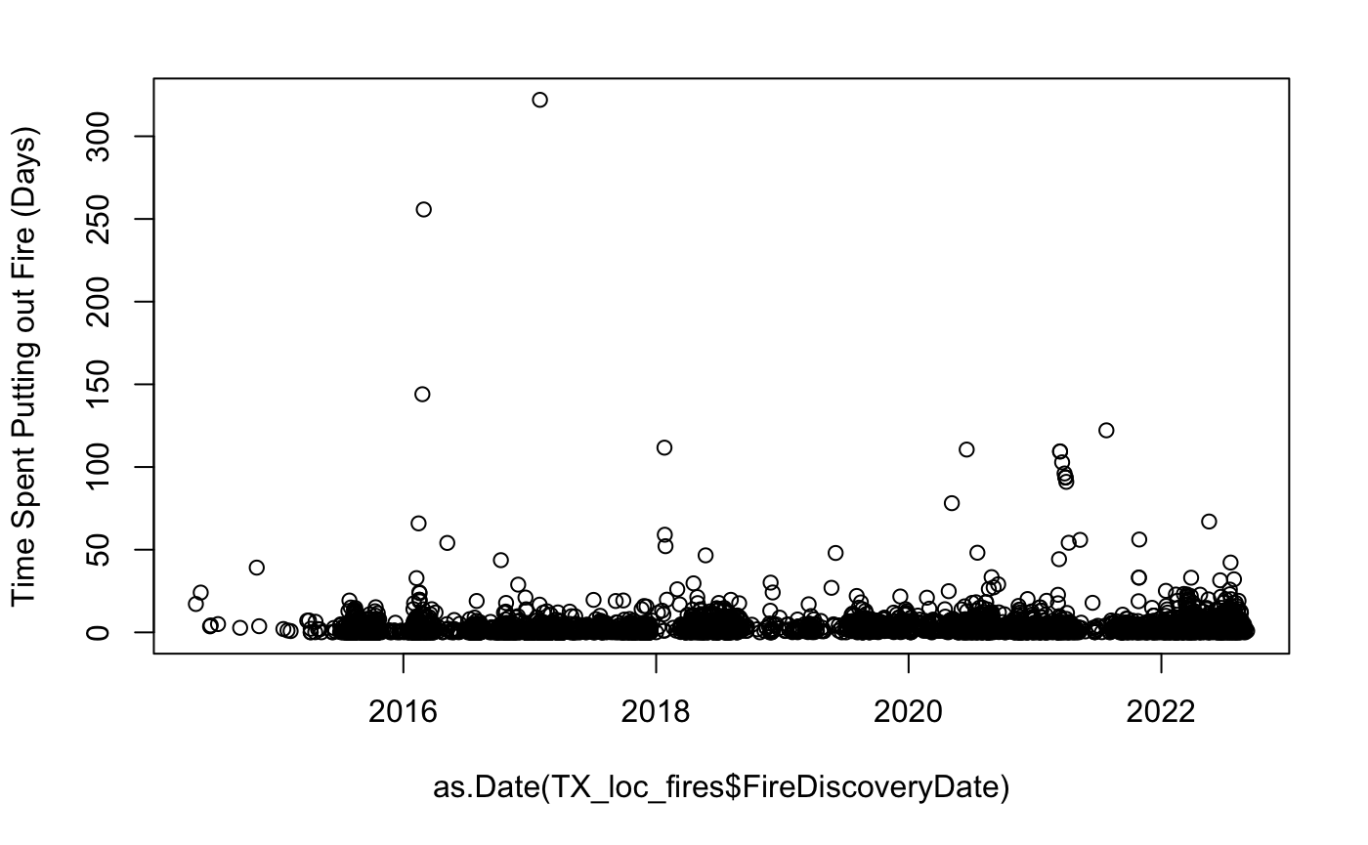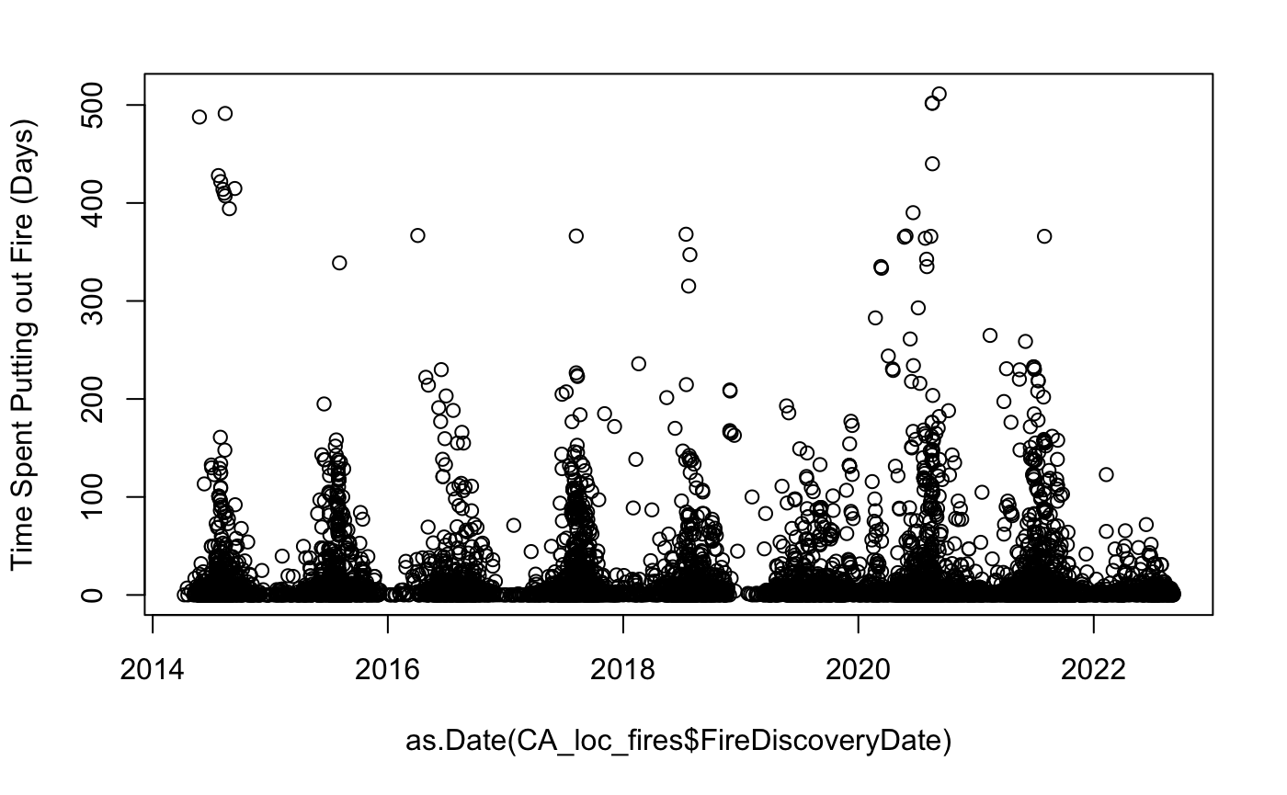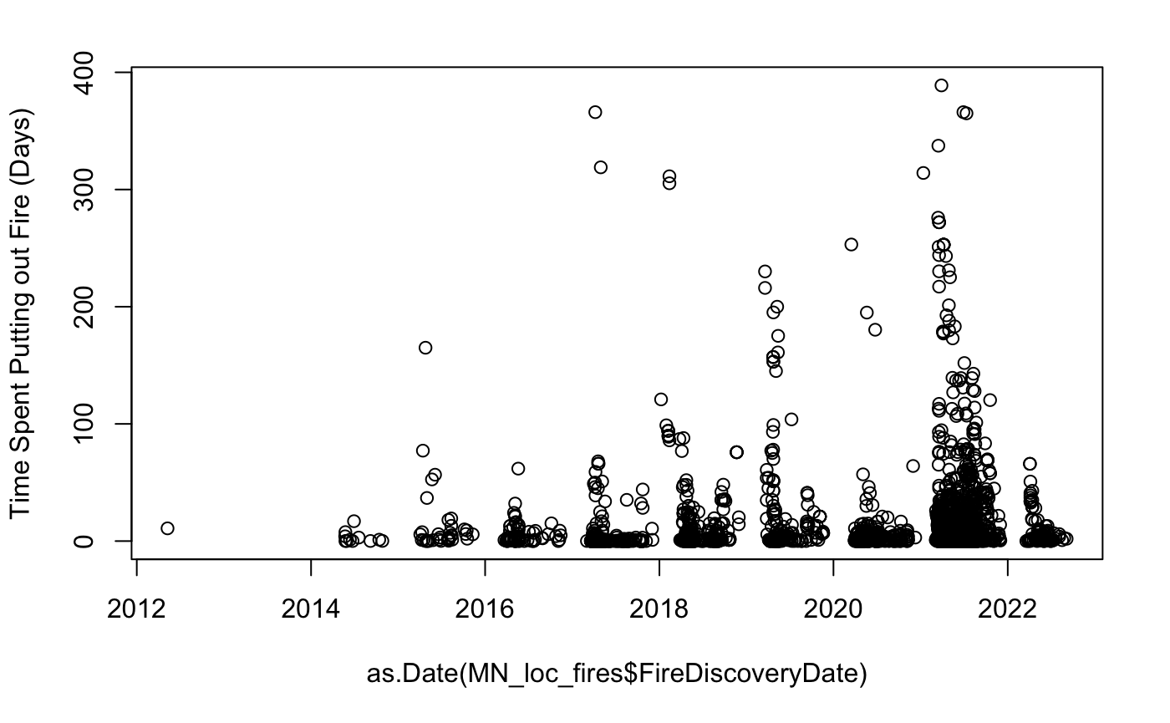

Our initial thoughts on the graphs above were that Texas seems to have the best ability to put out fires quickly (at least in this sample size) compared to California (CA) and Minnesota (MN). Both MN and CA seem to have a sort of seasonality where every year at some point, the amount of wildfires is far higher than any other time in the year. This makes sense to our general knowledge that CA has always had a big natural wildfire problem in the summer months (May-August). MN on the other hand also seems to have the problem of an increasing variation in time spent on putting out the fires, clearly the amount of fires is increasing over time which may be causing the local fire departments to strain in terms of getting people to put out numerous fires at the same time.

The second part of the density analysis is to look at another important variable in our dataset which is the **Fire Cause**. The plots below show the different densities of fire causes **(Human, Natural, Undetermined, and Unknown)**, and their respective times spent on putting out that type of fire. Again, we included the three states from the previous graphs: 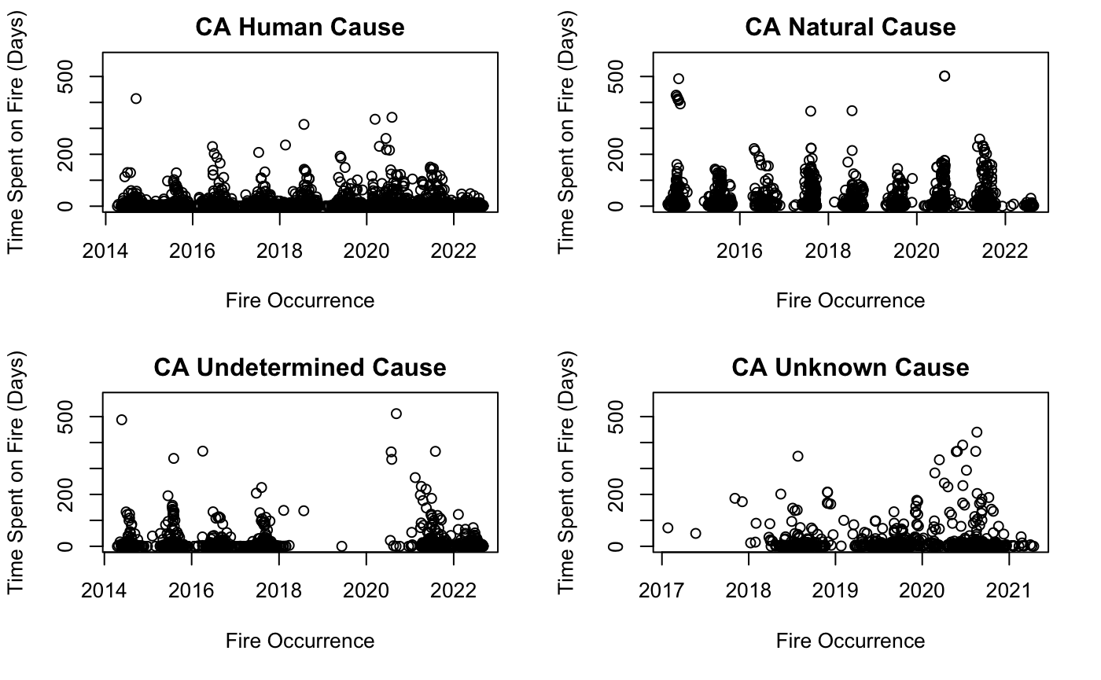

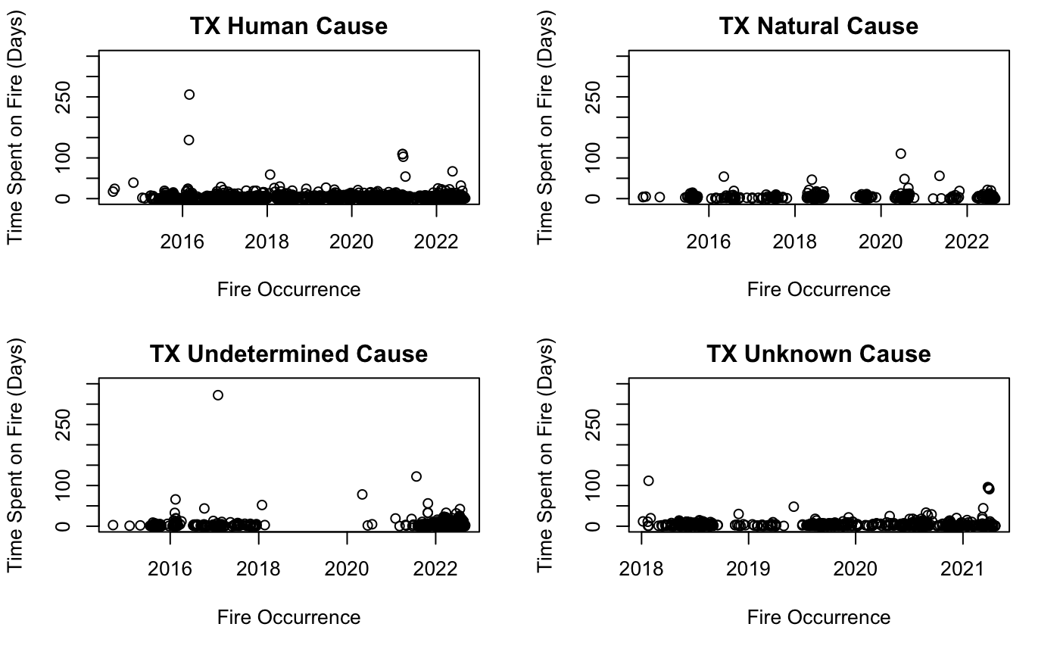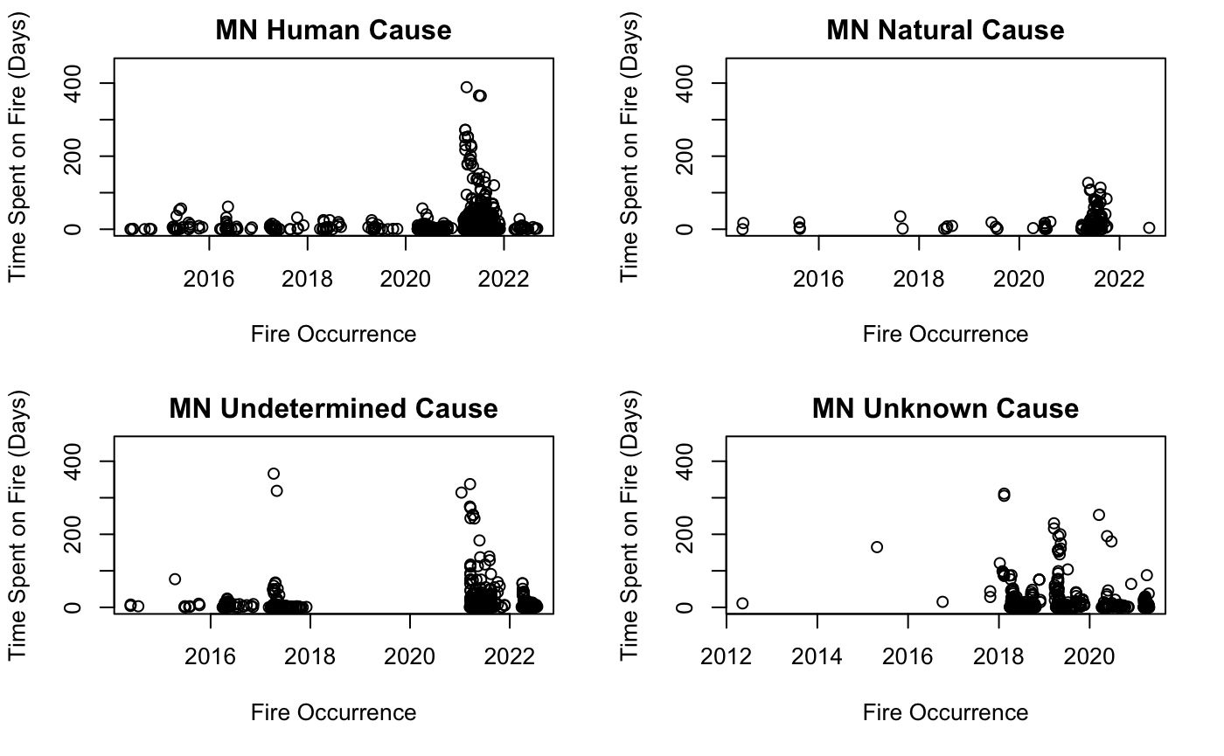

We can clearly see here that human and natural fires are the main causes of wildfires in the dataset, which is what we will choose to look at more clearly in our modeling and further analysis. As of now, we do not have enough information on undetermined/unknown fire causes to justify their results, so we will hold off on adding them into the model. If anything changes on that front and we do get some better information, they will be added in if needed.

The second part of our general data analysis would be to find the spatial distribution of our data in terms of wildfires. The idea here was to simply visualize how and where each fire cause occurs and how and where the more intense fires are distributed spatially. These are the graphs we extracted for each of the three states below:

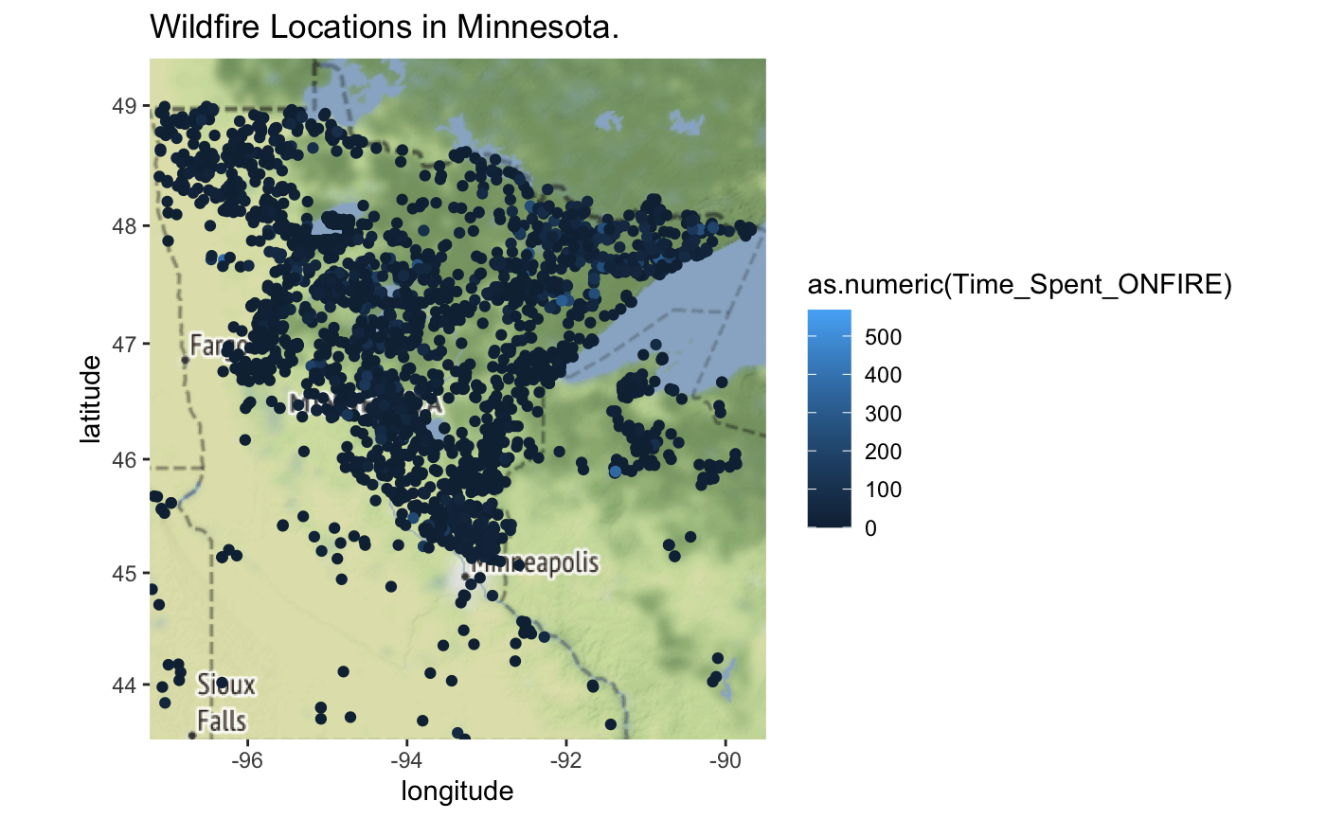

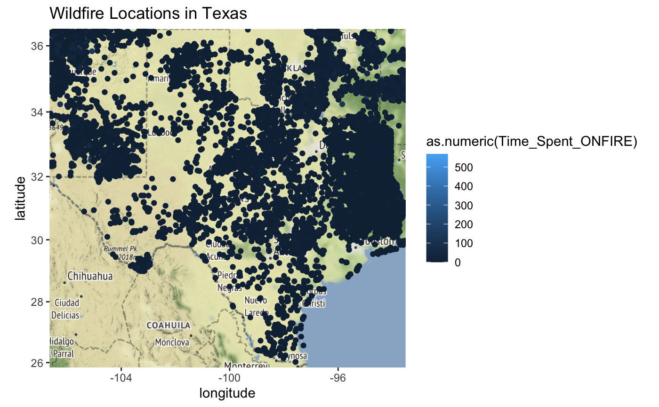

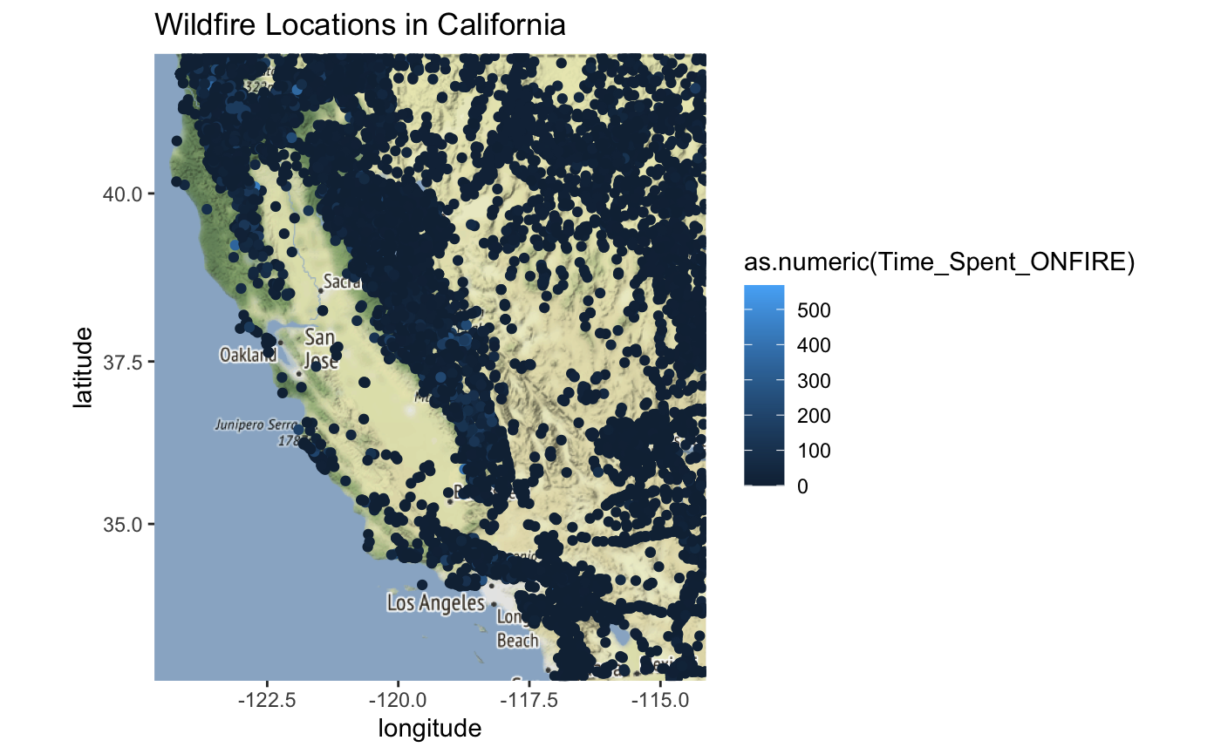



We can see how each state has its own unique terrain/environmental effects on where each type of fire might occur. This gives us enough information to go into modeling on how we can maybe predict the time spent on a fire based on its location (longitude and latitude) and possibly what the cause may be. For both models, we will continue using only the Texas data for all three datasets to simplify the strain.

**Data Modeling**

In the modeling part, we use two models:

**First Model: Gaussian Process Spatial Regression**

The objective is to predict how much time the fire will last in a specific location (S). The below figure shows the model formulation and variables.

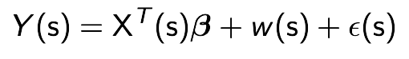











For W(S), we use: Gaussian Process with mean = 0 and covariance = 𝝈^2 * 𝙥 (r), where 0 < 𝙥 (r) < 1

1. We estimated 𝝈^2: applying a simple linear regression model (fit.lm) not considering the data as a spatial data and take the variance of the output
2. We estimated 𝙥 (r): By applying exponential covariance function with the following parameters:
   1. r = The distance between two locations
   2. 𝜙 = Spatial range parameter estimated as (the maximum of distance matrix / 3 * 2)

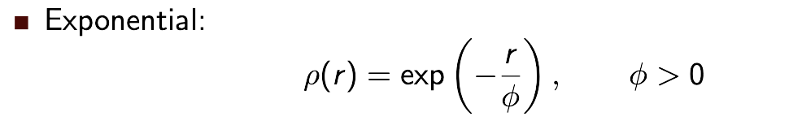

**Implementation**

We design the model using R-studio. We load necessary libraries needed to apply the model. We choose our data set to be the natural fire in the state of Texas with total data points of 530.Then, we split the data set into 80% training and 20% testing. Then we plot the data in a spatial coordinate for a visualization check as follows:

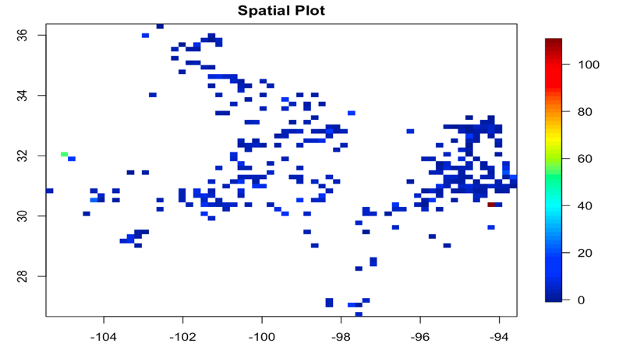

After that we fit the spatial model using the following code:

fit_mle <- likfit(data=Y.train,coords=coords.train,

trend = ~ X.train[,1]+X.train[,2],

fix.nugget=F,cov.model="exponential",ini = c(ini.sigma.sq,ini.phi))

**Results**

The result of fitting the model comes as follows:

## likfit: estimated model parameters:

## beta0 beta1 beta2 tausq sigmasq phi

## "-6.0596" "-0.2497" "-0.4386" "53.6561" " 0.0000" " 0.0000"

## Practical Range with cor=0.05 for asymptotic range: 0.0001159668

##

## likfit: maximised log-likelihood = -1446

We have estimated $β$ for the covariant variables (Lon,Lat) and also we construct the confidence interval to measure the significance of the variables and this is the result :

## lower.bond upper.bond

## intercept -18.5885878 6.4694772

## covar1 -0.3611500 -0.1383101

## covar2 -0.6549354 -0.2222032

So since the 0 is not in the range of the confidence interval for the two covariant variables hence we can conclude that the coordinates (Lon,Lat) are statistically significant to the model and the model has a spatial dependence.

**Validation**

To validate how good our model is, we utilize the model to predict on the testing data Then compare it with the real data and then calculate the Root mean square error (RMSE) as shown in the following code:

*# Doing prediction on the testing data*

krigecontrol=krige.control(type.krige = "OK", trend.d = ~ X.train[,1]+X.train[,2], trend.l = ~ X.test[,1]+X.test[,2], obj.model = fit_mle)

prediction<-krige.conv(data=Y.train,coords=coords.train,locations=coords.test,krig=krigecontrol)

*# Calculating the root mean square error between predicted VS real*

sqrt(mean(prediction$predict-Y.test)^2)

## [1] 0.1043633

As we can see, the RMSE is 0.10 which is very low which means our model performed well in predicting the real values.

**Visualization**

We used R-Studio to visualize the results, in particular a package called “flexdashboard” to initiate an interactive dashboard and to validate our result in a logical manner. This dashboard can be accessed through the following [Link](https://rpubs.com/alnuaimi107/Wildfire_project). As we can see in the figures below, most of the wildfires incidents that take time putting out the fire would be on the west part of Texas since there are less fire stations there and also far away from Texas major water resources.

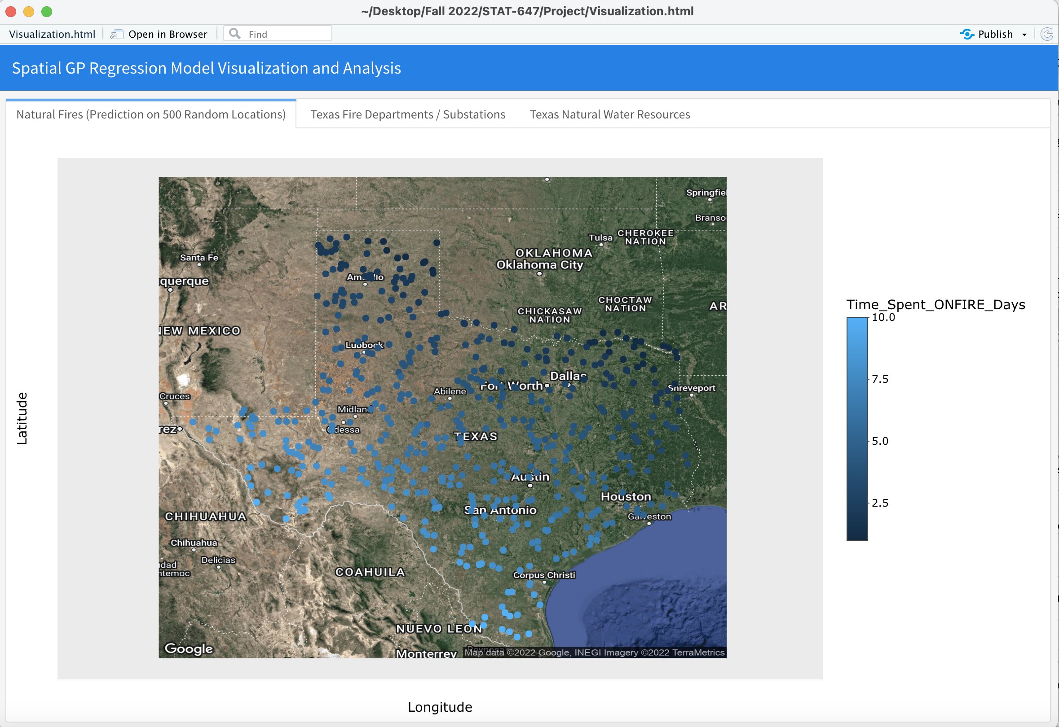

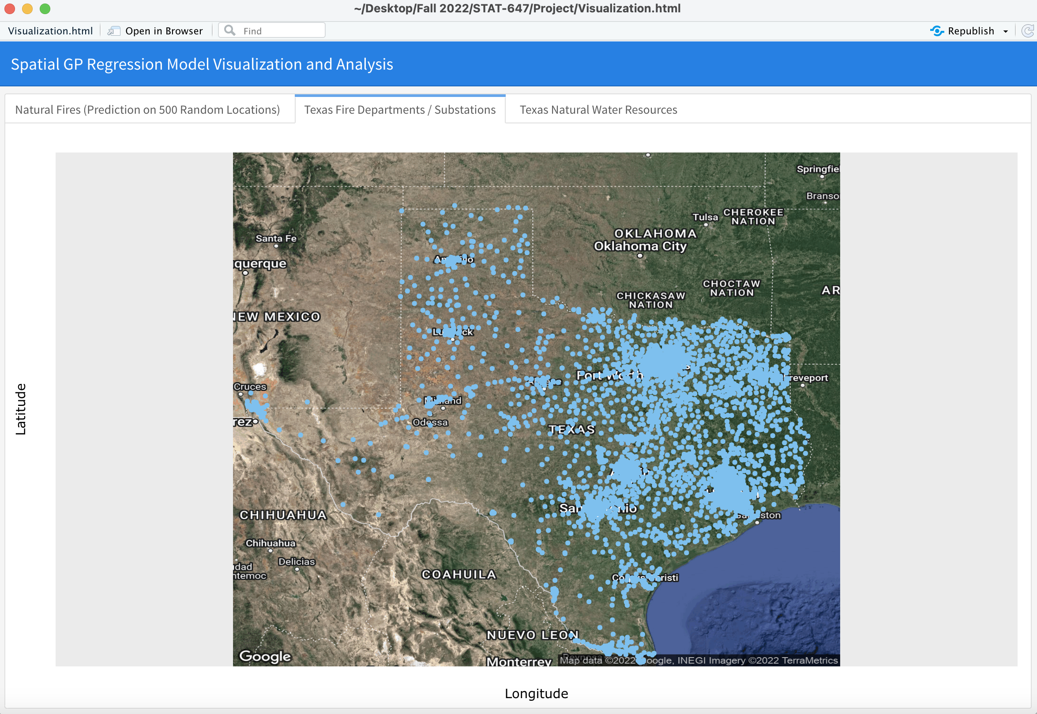

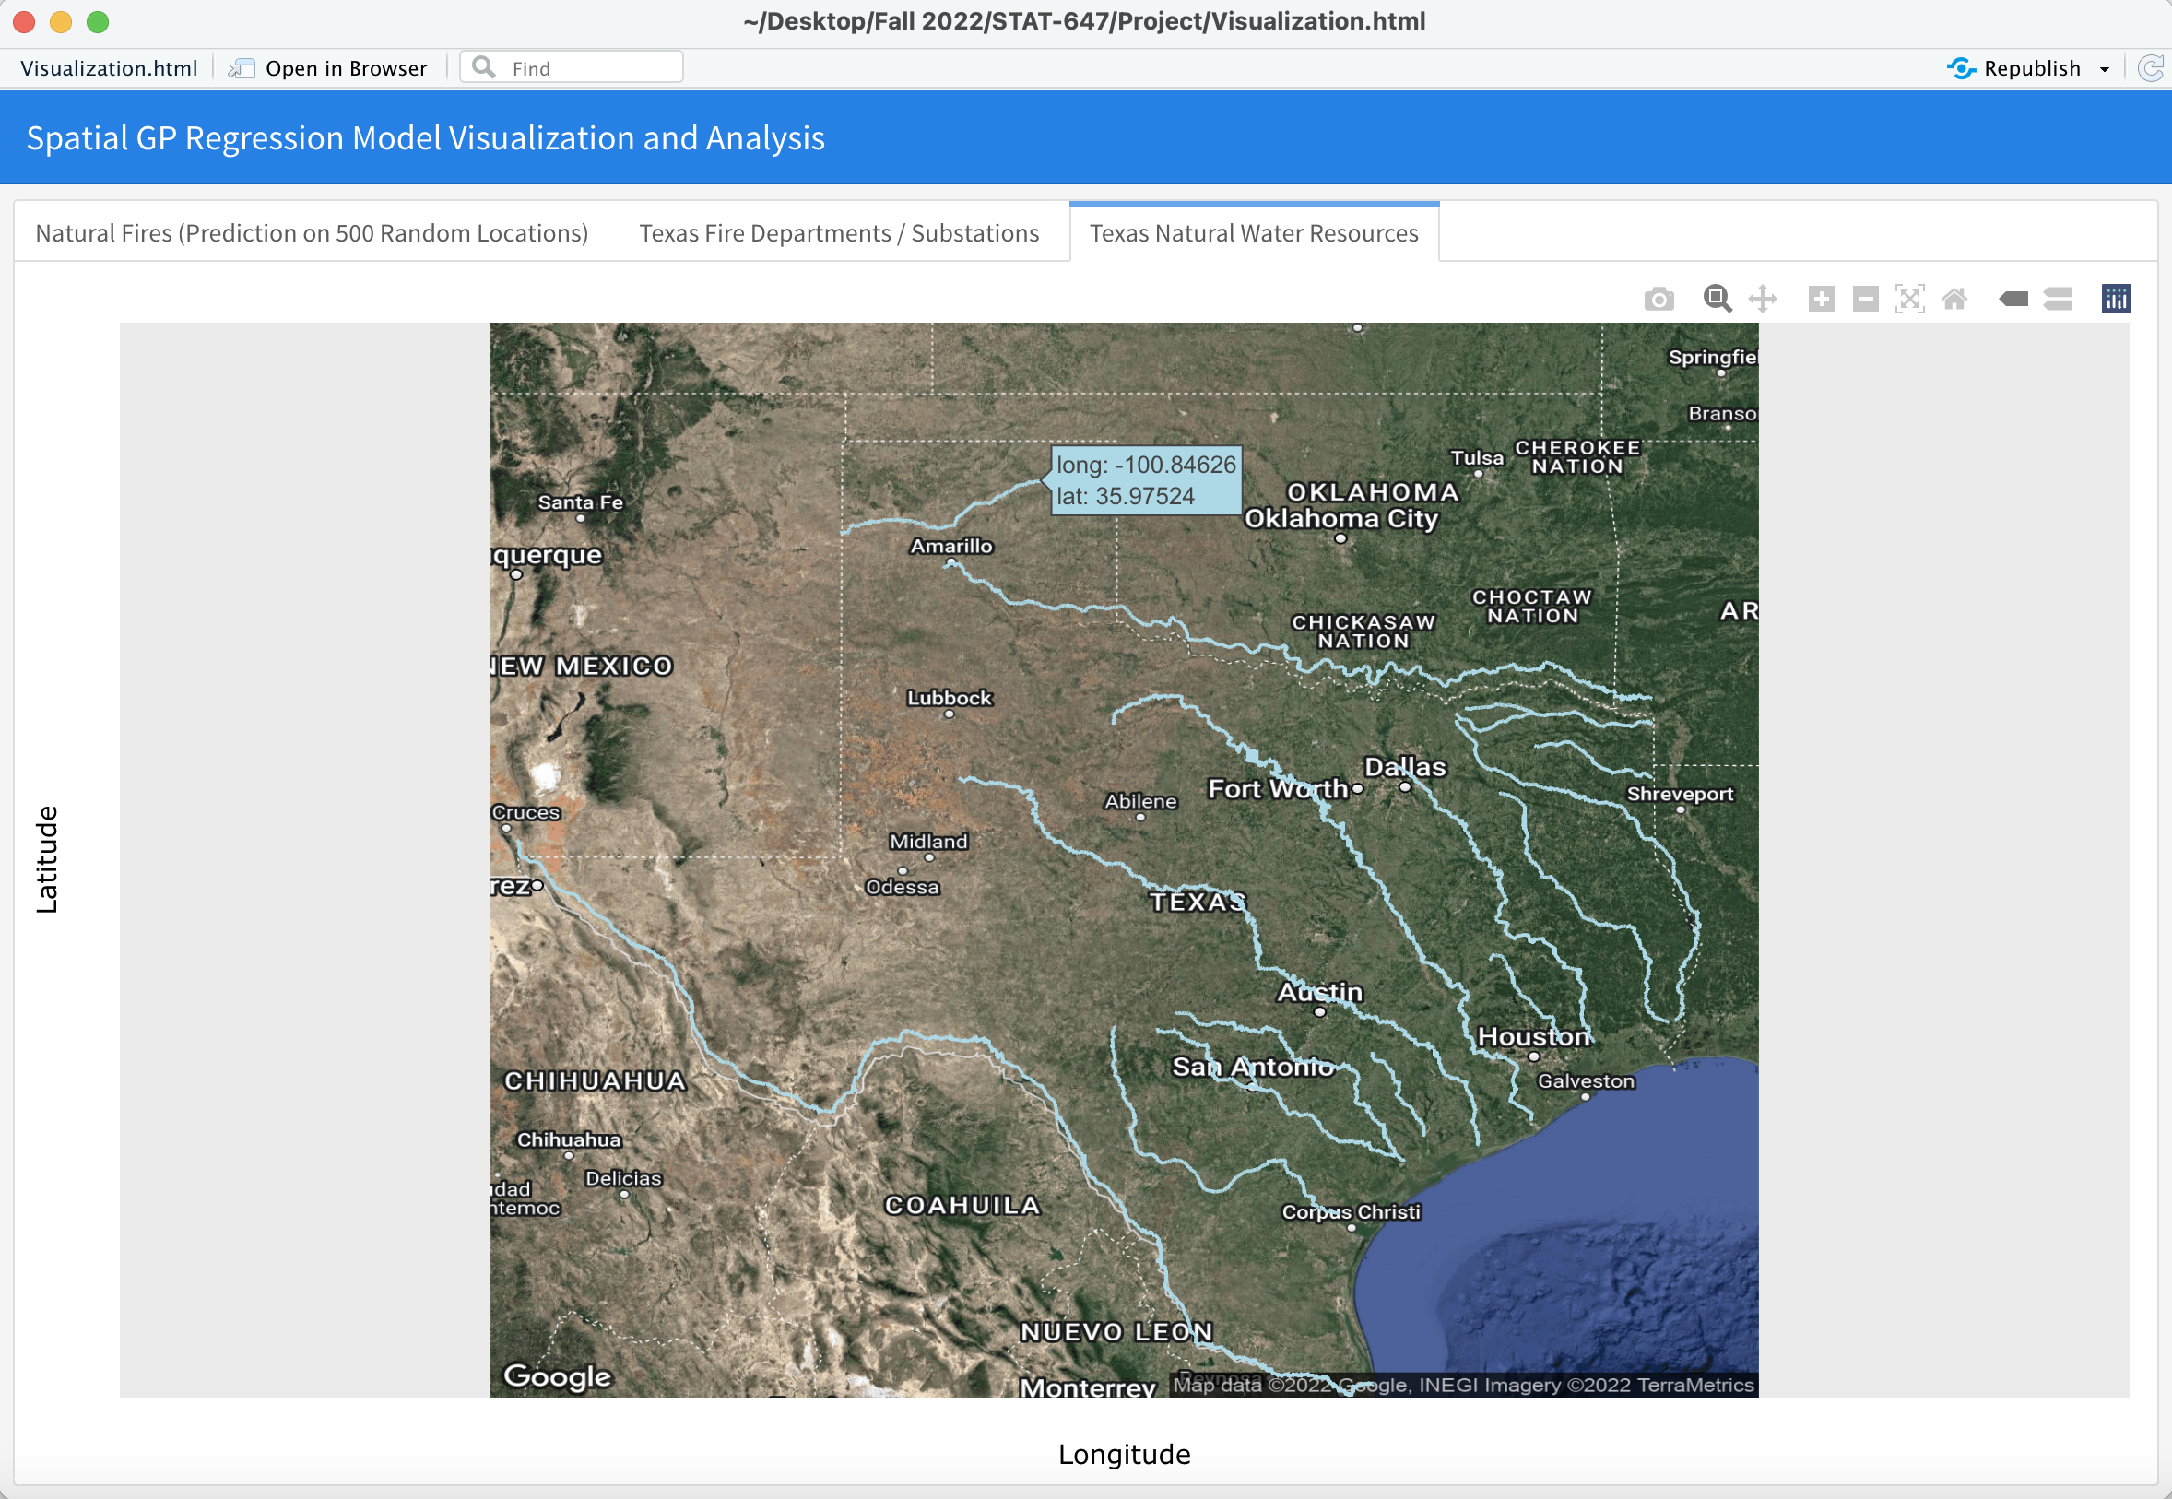

**Second Model: GAM - Generalized Additive Model**

For the second model we decided to use a Non-Gaussian-Spatio-Temporal model for prediction through the GAM model. GAM, or Generalized Additive Model is extremely similar to the GLM that is often used in regression, but in this case we use spatial-temporal data in place for the covariates to create spatial and temporal prediction plots. GAMs have additive components (smoothing functions) of the covariates which in our case are Longitude, Latitude and a time variable. Another thing to note for the model is the fact that our data is distributed in the shape of a negative binomial distribution so we will keep that in mind for the equation, and see the density below:

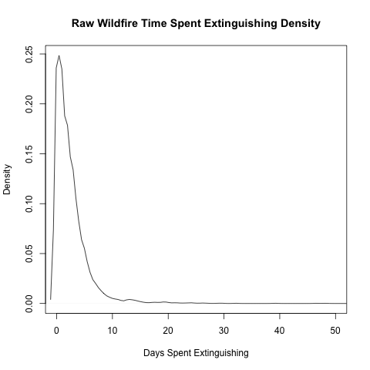

**Equation**

The GAM is formed and constructed as follows for our Texas wildfire data:

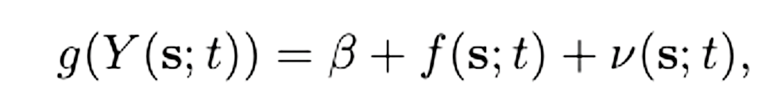

Prediction link function for **Longitude, Latitude, and Time** (Both YRs and Months) - The Response Y is **Time Spent Extinguishing the Fire**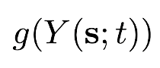

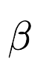

Spatio-Temporal Intercept

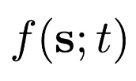

Smoothing function for Splines in terms of covariates for **Longitude, Latitude, and Time** (space and time)

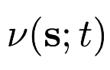

Spatio-Temporal Random Effect

**Results**

Using this model we want to see if we can recreate heatplot trends for the actual data points on a lattice grid that is 100x100 to get a general idea of how the data would look at all randomized locations across Texas. We want to achieve this with minimal prediction error to validate the model’s results. In our case we will show the trends in a general way with regards to time by showing **Yearly** and **Monthly** Average trends. As seen in the below function, we use **nb(link=”log”)** to get the results in a more orderly fashion:

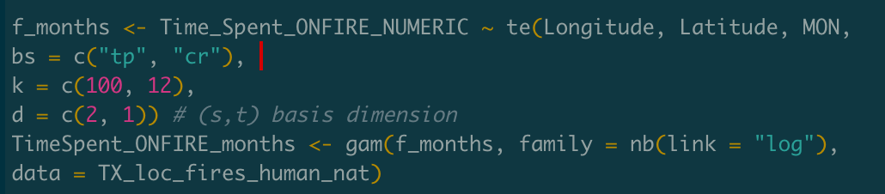

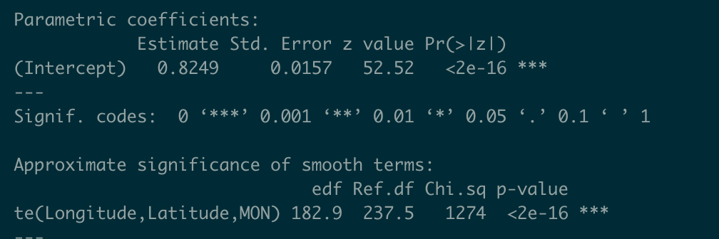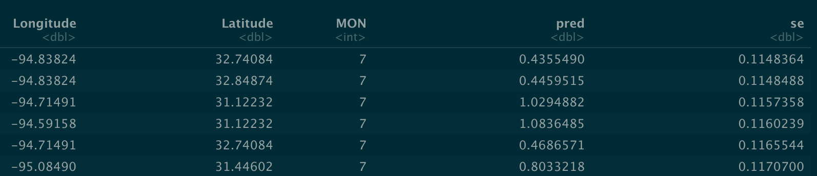

We can also see the distribution of the GAM predictions is relatively similar to the actual data distribution:

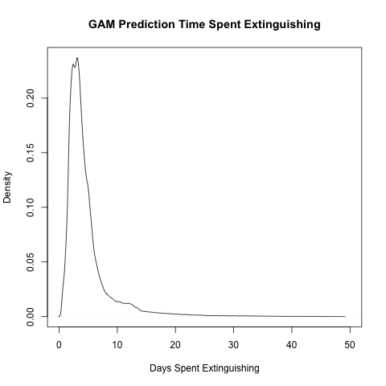

We can clearly see here the model has very significantly low p-values which helps our process moving forward, we can also clearly see in the final image that the standard error (**se**) of some predictions in the 7th month (July) are relatively low floating around .11. This will lead us to the validation of the models results in visualization by showing standard error across the map of Texas.

**Visualization (All Plots provided in RPubs Link)**

**RPubs Link for Visualization:** <https://rpubs.com/BKlein1812/981296>

The RPubs contains 7 tabs consisting of initial yearly and monthly trends of the raw data, 4 plots split into Years (2014 - 2022) and Months (1-12) for **prediction** and **prediction standard error**. For the dark blue/grey prediction standard error heatplots, we can judge them by seeing the outline of the state of Texas, the darker the outline, the closer our standard error is to 0. The final two plots are a combination of Yearly and Monthly predictions, and a final standard error spread plot that will be explained further in the next section. Again, all plots for visualization described above will be provided in the RPubs link.

**Validation**

In terms of validation we can simply look at our monthly and yearly standard error in the RPubs link for our visualizations. The last tab as we mentioned above in the RPubs link shows a yearly spread of prediction points and their standard error. To validate this model I decided to use the minimum distanced prediction point to each of our 4,693 actual data points to try and create almost replica plots for predictions. Below are the plots for standard error and the distances each of those points are from the closest actual point in our dataset. All are within 3.5 miles which gives us a good idea of what that area surrounding will be like in terms of wildfire intensity during that specific year:

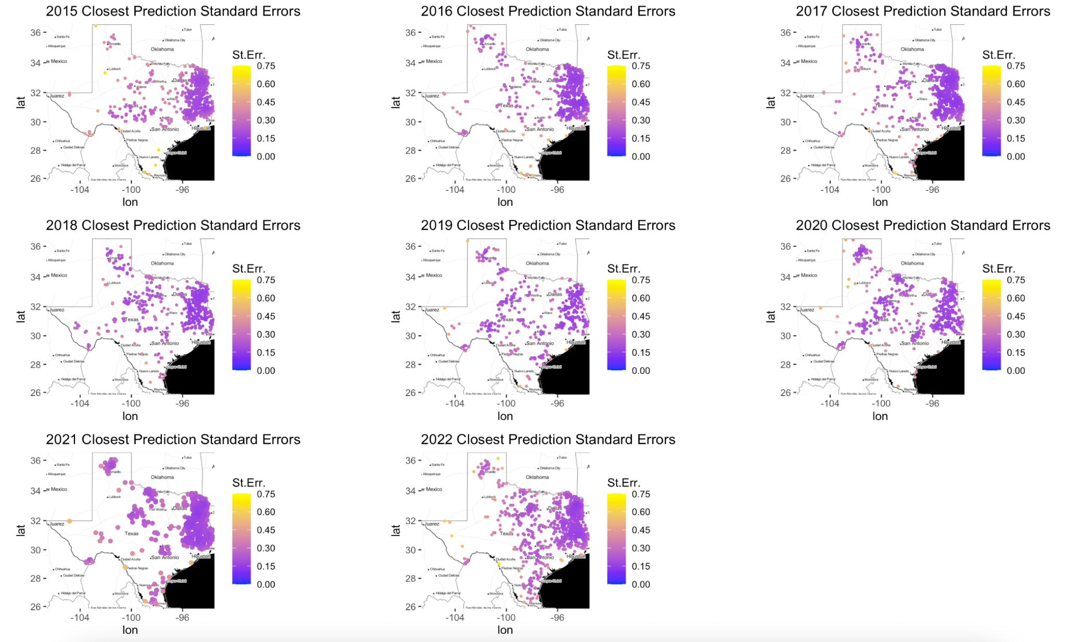

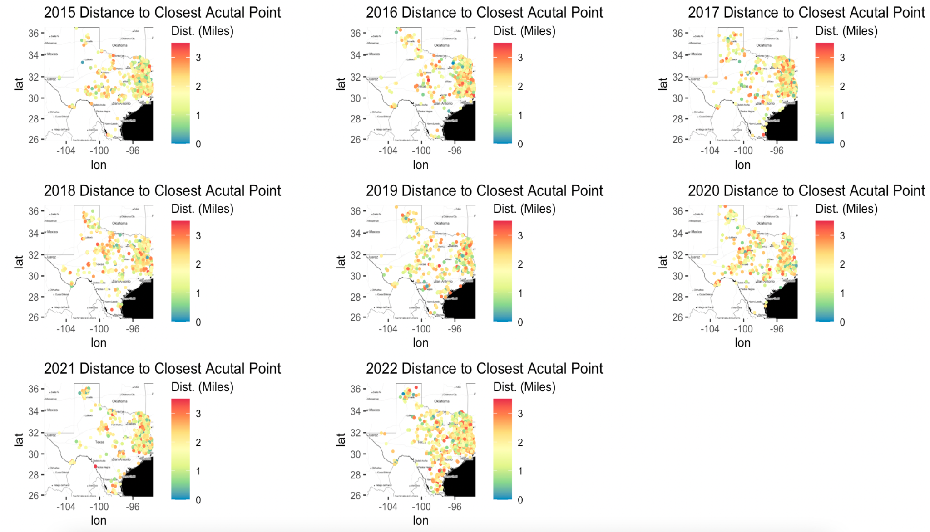

**Conclusion**

Some conclusive statements we can come to based on our visualizations and validation of standard errors for the second model:

* It is clear that time (especially Years) has a massive impact on the severity of the Human and Natural caused wildfires in Texas (**specifically 2018 spike**). Monthly predictions showed what we would expect in terms of higher intensity during warmer months (April - August) and cooler intensity during colder months (1-3).
* With the showing of standard error spread in the RPubs link we also see a spatial dependence visually towards East Texas in terms of minimized standard error in our predictions from the GAM model. The high density of points in that region consistently gave us our smallest error across all predictions no matter the year or month, (**reference to RPubs last tab**).So clearly spatial clusters will tend to have lower error compared to points in less populated areas that only contain singular points.
* Time seems to have a more significant impact in our opinion in terms of the intensity of wildfires, clearly over the past 2-3 years it has come to a higher plateau, but the spike was clear and significant in 2018 for time and clearly in the western more desolate areas of Texas concerning causes by Humans and Nature.

**Discussion/Future Steps**

Now that we have two models that work correctly, we can consider the future step of applying a forecasting method to the GAM and spatial regression model to show daily or monthly predictions for wildfire intensity. This implementation could save the state of Texas millions of dollars in infrastructure damage that can pile up during bad wildfires. This forecasting would have them better prepared to fight those fires and limit the amount of time for them to spread.